**Assignment 1**

1. **Write a java program to find the area of rectangle**

**Source Code :**

import java.util.Scanner;

class AreaOfRectangle{

public static void main(String args[]){

Scanner sc = new Scanner(System.in);

System.out.print("Enter length of a rectangle : ");

int len = sc.nextInt();

System.out.print("Enter height of a rectangle : ");

int heig = sc.nextInt();

System.out.print("Area of a rectangle is : "+(len*heig));

}

}

**Output :**

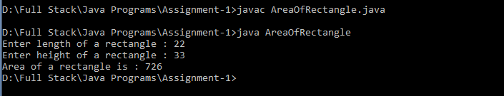

1. **Write a java program to check the given no is Armstrong or not(153 is Armstrong no 1*1*1+5*5*5+3*3*3=153)**

**Source Code :**

import java.util.Scanner;

import java.lang.Math;

class Armstrong{

public static void main(String args[]){

Scanner sc = new Scanner(System.in);

System.out.print("Enter a number : ");

int a = sc.nextInt();

int rem,num,count=0;

num=a;

int num1=a;

double result=0;

while(num != 0)

{

num /= 10;

++count;

}

while(num1>0){

rem=num1%10;

result=result+Math.pow(rem,count);

num1/=10;

}

if(result==a)

System.out.println(a+" is an Armstrong number.");

else

System.out.println(a+" is not an Armstrong number.");

}

}

**Output :**

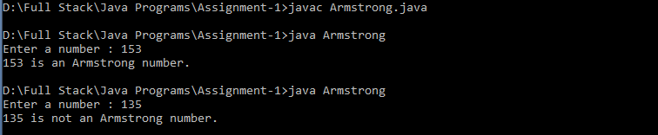

1. **Write a java program to check the given no is palindrome or not.**

**Source Code :**

import java.util.Scanner;

public class Palindrome{

public static void main(String args[]) {

Scanner sc = new Scanner(System.in);

System.out.print("Enter a number: ");

int n= sc.nextInt();

int n1=n,rem,res=0;

while(n1>0){

rem=n1%10;

res=(res*10)+rem;

n1/=10;

}

if(n==res)

System.out.print(n+" is a Palindrome");

else

System.out.print(n+" is not a Palindrome");

sc.close();

}

}

**Output :**

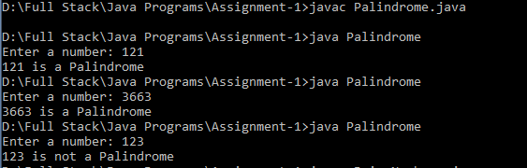

1. **Write a java program to generate first N prime numbers.**

**Source Code :**

import java.util.Scanner;

class PrimeNumbers{

boolean isPrime(int p){

int temp;

boolean isPri=true;

for(int i=2;i<=p/2;i++){

temp=p%i;

if(temp==0){

isPri=false;

break;

}

}

return isPri;

}

public static void main(String args[]){

Scanner sc = new Scanner(System.in);

PrimeNumbers pn=new PrimeNumbers();

System.out.print("Enter a number : ");

int n = sc.nextInt();

for(int i=2;i<n;i++){

if(pn.isPrime(i))

System.out.println(i);

}

}

}

**Output :**

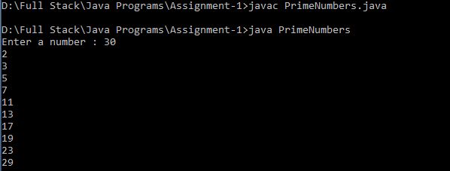

1. **Write a java program to print even numbers in between given two numbers.**

**Source Code :**

import java.util.Scanner;

class Even{

public static void main(String args[]){

Scanner sc = new Scanner(System.in);

System.out.print("Even number with in the range \nEnter the starting range : ");

int n = sc.nextInt();

System.out.print("Enter the ending Range : ");

int n1 = sc.nextInt();

System.out.println("Even numbers between "+n+" and "+n1+" is as follows : ");

for(int i=n;i<n1;i++){

if(i%2==0)

System.out.print(i+" ");

}

}

}

**Output :**

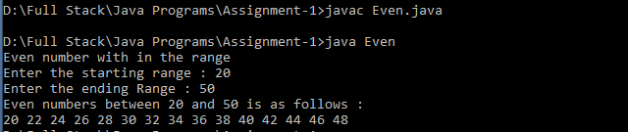

**1. What is Abstraction?**

Abstration is hiding the internal details and showing only the functionality. In Java, it can be achieved with either abstract classes or intefaces

**2. What is Encapsulation?**

Binding code and data together into a single unit is known as "Encapsulation". The functionality where we can change the implementation code without breaking the code of other components.

**3. What is JDK?**

The Java Development Kit(JDK) is one of three core technology packages used in java programming , along with JVM and the JRE. It a software development environment used for developing java applications and applets.

**4. What is JVM?**

A Java Virtual Machine(JVM) is a virtual machine that enables a computer to run java programs. It is available as a part of java software and whose role is reading the line by line of byte code and converted into native understanding format of Operating System.

**5. Define Inheritance**

The process of obtaining data members and methods of one class into another class is called "Inheritance".This concept is also known as re-usuability or sub classing / derivation / extendable classes.

**6. How java achieved platform independence?**

Java achived platform independence because it satisfies the following properties :

It takes same amount of memory space on all operating systems.

It contains the special programs and whose role is converting native understanding format of one Operating system into native understanding format of another Operating System that special program is nothing but **Bytecode.**

**7. Write the syntax of main function.**

class <classname>{

public static void main(String args[]){

//Statements

}

}

**8. What is conditional operator?**

Conditional Operator is used to evaluate a boolean expression based on the condition given.

**Syntax:**

condition ? statement 1 : statement 2

// statement 1 - true

// statement 2 - false

**9. How many data types in java?**

There are two categories. They are :

**Primitive data types**

* Boolean
* byte
* char
* short
* int
* float
* long
* double

**Non-primitive data types**

* Strings
* Arrays
* classes
* interfaces

**10. What is constant? How it is declared?**

A constant is a variable which cannot be changed throughout the program. we can use a keyword called 'final' to make a variable constant.

**Syntax:**

variable_name = value;

final variable_name = value;